PROJECT PROFILE

PROJECT TITLE: Fiwi – University/College Management System

DEVELOPED FOR: Project Assignment of Degree of MSc in Computer Science

DEVELOPMENT FRAMEWORK: Flutter

INTEGRATED DEVELOPMENT ENVIRONMENT: Android Studio, Microsoft Visual Studio Code

CODING LANGUAGE: Dart

DATABASE: Firebase Realtime Database

OBJECTIVES: To Provide Students and Teacher a digital medium to get their work done.

Introduction to Project

With tremendous increase in technology, Information Technology is the first developing field. Technology, which is in vogue might become redundant tomorrow. This ever-changing scenario makes it possible to provide the latest & most modern IT solution to various business & institutions.

Project Fiwi helps the institution, the student and the faculties. The application focuses on Highly Secured Password less Google Authentication and Phone Authentication for login System, Realtime Timetable, Notification System, Attendance System, Library System which will help the students and faculties alot in their daily management. These are traditionally been anchored by many third-party apps, where some features weren’t offered by any other apps at all.

Fiwi is the process of organizing all the required data for a student, faculty and admin at his/her fingertips. It will help to get various information like the personal details of students, their daily, weekly, report per semester attendance monitoring, Realtime timetable for their classes, for semesters or exams. They can get update on different holiday notice, fee payment notice, various circular regarding their curriculum etc. directly through their platforms. This system helps faculties & students in recording data appropriately. It is also less time consuming and is more convenient to get all the records in Fiwi

Literature Review

Several studies have explored the benefits of college management systems. For example, a study by Kumar et al. (2017) found that college management systems can improve the efficiency of administrative processes, reduce errors, and provide greater transparency and accountability. Another study by Hussain and Fasihuddin (2019) found that college management systems can help to improve communication between teachers, students, and parents, and provide real-time access to academic information and performance data.

However, there are also challenges and limitations associated with college management systems. For example, a study by Pius and Idakwo (2020) found that the implementation of college management systems can be hampered by factors such as inadequate training, lack of technical expertise, and resistance to change. Other studies have noted concerns about data security and privacy, as well as the potential for systems to be misused or abused.

Despite these challenges, there is growing interest in the use of college management systems to improve the efficiency and effectiveness of higher education. As such, further research is needed to explore the potential benefits and limitations of these systems, and to identify best practices for their implementation and use.

Overall, the literature suggests that college management systems have the potential to provide significant benefits for colleges and universities, including improved efficiency, communication, and access to data. However, there are also challenges and limitations associated with these systems that must be carefully considered and addressed.

Requirement analysis

Requirement analysis

In this chapter we will discuss & analysis about the development process of Fiwi – Artificial Inteligence including System Requirement System (SRS) & Data Flow Diagram (DFD). DFD provides a view of how the system or business flows that able to increase the efficiency & effectiveness to achieve system objectives.

Software Requirement Specification (SRS)

General Description

Product design

Fiwi is a Mobile application, which can help user (Students & teachers) access the student related data. It reduces the risks of paper work such as file lost, file damage & time consuming.

Problem Specification

The problem occurred before having computerized system includes;

* File lost: When no digitalized system is implemented, the file always lost because of human & environment. Sometimes teachers did not keep the records in its original place & there is misplaced of students’ records. Due to this messy environment the missing of file occurred.
* File damaged: In the other possibility, the files/ record will be damages due to some accident. Due to electrical short circuit & some natural disasters will damage the file record.
* Difficult to search a record: Without digitalized system, if a student / teacher wants to know about his / her records they had to search a lot in different paper records for their data. It is time consuming and is a messy work to retrieve the data.
* Space consuming: After a long duration, there will be a lot of records of different students. Finally, the paper records will be space consuming & there will be no place to keep the file.
* Cost consuming: paper is required to add every new record. After long period of time cost to buy a paper can be high. On the other hand, the institution needs to employ more staffs to solve the queued problems of students. In the institution, one or two staff is not enough to handle such paper work queries.

System objectives

* Improvement in control and performance

The system was developed to overcome the current problem occurred in curriculum. The application must be able to validate the user, store, record and bug free.

* Save cost

After implementing the digital system less staff can manage all the necessary work in the institution. With the aids of digital system institution can save the paper cost & also save the cost of hiring employees.

* Save time

Teachers and students are able to browse the record in short time by tapping on their screen. Comparing to the previous system of work, everyone can save a lot of time.

System Planning

The development process of the student management app is being carried out in this chapter as well as the app objectives, scope, schedules, specification & its use.

Project Aims & Objectives

The aims & objectives of Fiwi is to provide high protected security, real-time timetable facility, real time attendance facility, library management facility. It also has due time notification facility, profile facility etc. all these features in app is being provided to make the work effortless for the faculties. The succession of Fiwi will also be evaluated through this sub chapter.

The project objectives are:

* To eliminate the paper work
* To record all the details of the student and for the students in digitalized system. So, there is no chance of data manipulation.
* To design a user-friendly Graphical User Interface (GUI), which suits the user & attract them immensely.
* To update with important information to students in due course of time.

Background of Projects

Fiwi application is a student app, which can be used in institution with large numbers of facilities. This application is meant for the admin & the user. The application is being designed & developed to provide a real-time attendance, real-time timetable facility, library facility, notification facility, with secured Google and Phone authentication access. This is done to reduce the paper-based work & all the data will be available for the admin & users digitally.

Fiwi has all type of student requirement facility. First the user has to sign up by entering their some details & user can login by using his/her Google account and Phone number and can enjoy features of Fiwi. The data entry or fetching task is to be done by the admin & then it is being usable by the registered student. This will help to store all the efficient & related data in a digital way.

The information will reach to each student in just their cell phone. They will get all the notification of day-to-day notice, exam dates, fee payment date etc. They will get their daily routine of institution time to time. The attendance system will help them to know the number of class attend by each student.

The facilities will be able to fetch all the related & required data of each student. They could also know about their class related details in just their cell phone through this app.

Project Scope:

In this sub-chapter project scope is bring focused on different modules that are being implemented in Fiwi.

At here we’ll describe our own part, which is integrated in Fiwi, that can be used by both teachers & students.

University/College management system

Login system

It is the authorization & authentication part of the app. This module is to be used by the user for login or sign up with highly secured Google Authentication Login and Phone Authentication Login.

Profile system

This is the second module in Fiwi, which is being fill up by the user at the time of signup. In this module, the student will have to enter his / her all the required data asked in the module. This will make available of all the necessary data of a student to the admin.

Timetable system

It is the third module in Fiwi. It is the real-time timetable system in which all the necessary timetable is being provided to both user & admin. The exam timetable, the holiday update, the class timetable all updates will be available to the student daily.

Notification system

It is the fourth module in Fiwi. It will help provide all types of notification. The teachers & students like exam notification, class timetable notification, attendance detail etc. to the students & the admin will get updated of all.

Attendance system

It is the fifth module in Fiwi. It is the real time attendance system in which the admin will be able to know the information of attendance in classes, in exams of each student. The student will also get the regular update of number of classes attended by him / her.

Library System

It is the sixth module in Fiwi. Here Student can issue a book and it got notified to the librarian by notification. Then Issued book and the Student name will appear on the Issued book section of Librarian. Then Librarian decide whether to accept issue or reject it. On the time of returning book Librarian can search for Student name or issue ID and complete the return book process.

1.4. Outline of Approach / methodology used

Fiwi is being developed by Microsoft Visual Studio code, Android studio and the hybrid database is being developed in fire base & Hive

Agile is a time bound, iterative approach to software delivery that builds software incrementally from the start of the project instead of trying to deliver all at once.

The Agile Software Development Life Cycle (SDLC) model is a combination of iterative and incremental process models focusing on process adaptability & customer satisfaction by rapid delivery of working software product into small incremental builds.

It works on various areas like

* Planning
* Requirement Analysis
* Design
* Coding
* Unit Testing
* Acceptance Testing

At the end a working product is displayed to the customer & important stakeholders.

At first, we have to do the planning of the application about its back-end & front-end & its User Interface. Then, the requirement phase starts in which we analyse through different sources to fulfil the requirement of a stable application. Next is the designing phase in which the UI designing work is done. It is the important part of the application, which will show us how the app will be viewed to the user. Then comes coding phase in which codes are being written for functional of the application. Then we tested each module individually to check its better functionality in the phase of unit testing. In the final phase comes the acceptance testing in which we tested the whole functionality of the application by merging all the module into it.

Development environment

* Software
  + Operating system

Windows 10 is selected as my developing OS, because it is updated with latest security features. The advantage of windows 10 over other Operating System is that windows is widely used all across the globe due to which many people find easy to use the OS. We choose windows 10 Home to avoid any kind of compatibility with any software or hardware we are going to use for project.

* + Database

Firebase Realtime Database is a NoSQL database built for global apps. Firebase Realtime Database is a first, fully managed, serverless, cloud-native NoSQL document database that simplifies storing, syncing & querying data for your mobile, web & IoT apps at global scale.

Firebase Realtime Database is provided by fire base. Fire base is a mobile & web application development platform developed by firebase, Inc in 2011, then acquired by Google in 2014. As of October 2018, fire base platform has 18 products which are used by 1.5million apps. It provides a real time database & back-end as a service. The service provides application developers an API that allows application data to be synchronized across clients & stored on fire base cloud. The platform provides client libraries that enables integration with Android, iOS, JS, Java, Objective-C, Swift & Node.js applications. It also provides many more features like Google Analytics, fire base cloud messaging, fire base Auth, fire base storage, fire base hosting, ML Kit, crashlytics, fire test lab, Admob and fire base dynamic links. These addons help developers to develop highly stable, scalable applications for their clients.

* + Development tools

Android Studio is the official integrated development environment for Google's Android operating system, built on JetBrains' IntelliJ IDEA software and designed specifically for Android development. It is available for download on Windows, macOS and Linux based operating systems.

Visual Studio Code is a source-code editor developed by Microsoft for Windows, Linux and macOS. It includes support for debugging, embedded Git control and GitHub, syntax highlighting, intelligent code completion, snippets, and code refactoring.

Flutter is an open-source UI software development kit created by Google. It is used to develop applications for Android, iOS, Windows, Mac, Linux, Google Fuchsia and the web. The first version of Flutter was known as codename "Sky" and ran on the Android operating system.

* + Programming language

Dart is a client-optimized programming language for apps on multiple platforms. It is developed by Google and is used to build mobile, desktop, server, and web applications. Dart is an object-oriented, class-based, garbage-collected language with C-style syntax. Dart can compile to either native code or JavaScript.

* Hardware
  + Processor: intel Pentium processor
  + RAM: 8 GB DDR4

1.6. Operation environment

The table shown below is the minimum requirement for Fiwi.

|  |  |
| --- | --- |
| Processor: | Any 32-bit ARM Processor |
| OS: | Android 5.0 or above |
| Memory: | 2GB or above |
| Storage space: | 8GB |
| Internet speed: | 5KbPS (minimum) |

System Design and Programming

Data Flow Diagram

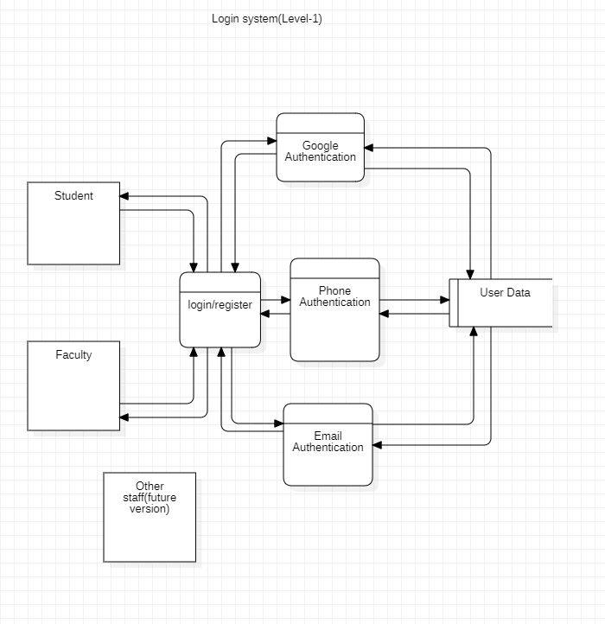

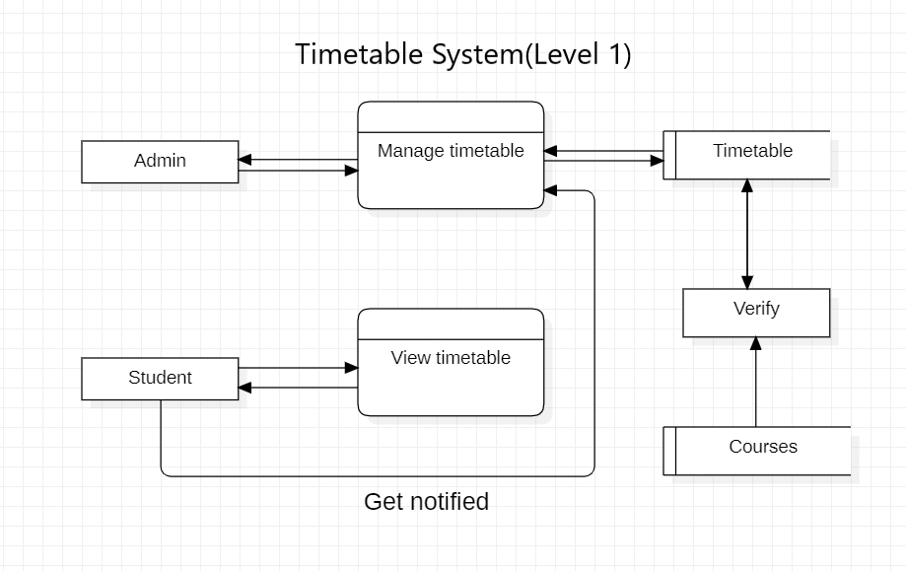

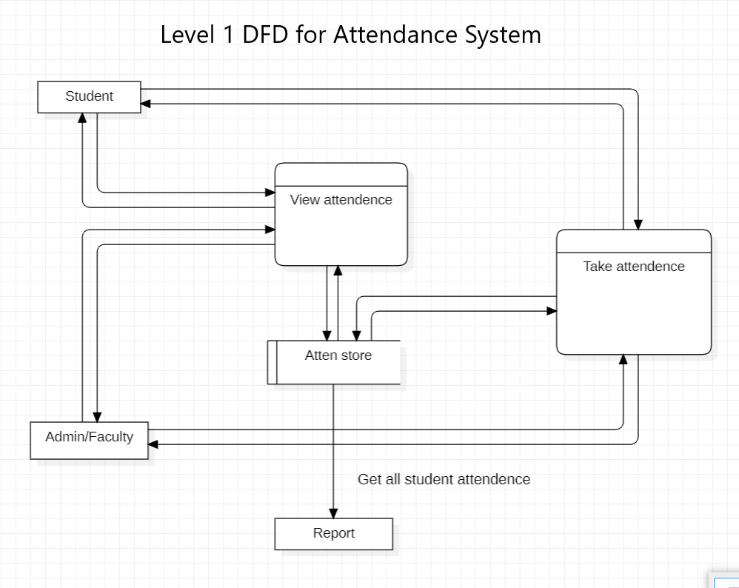

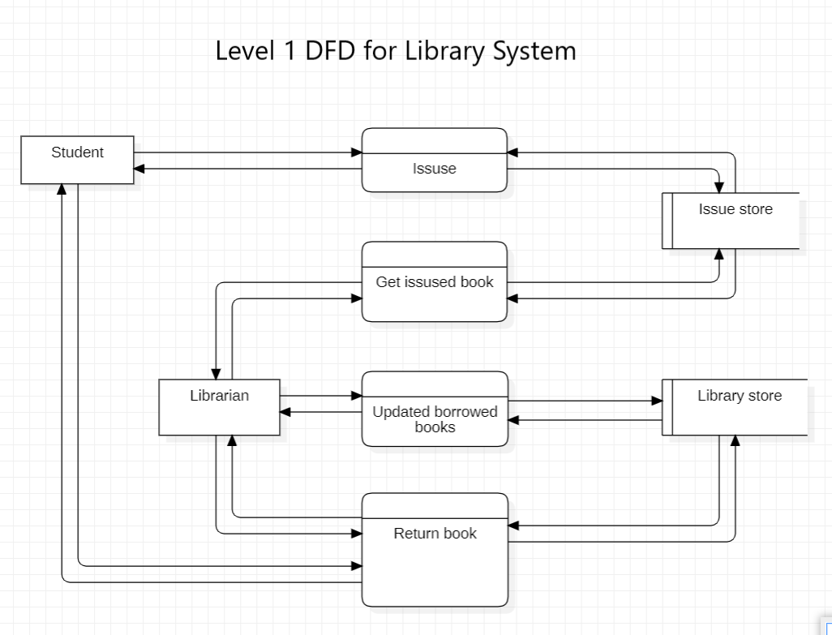

Usecase Diagram

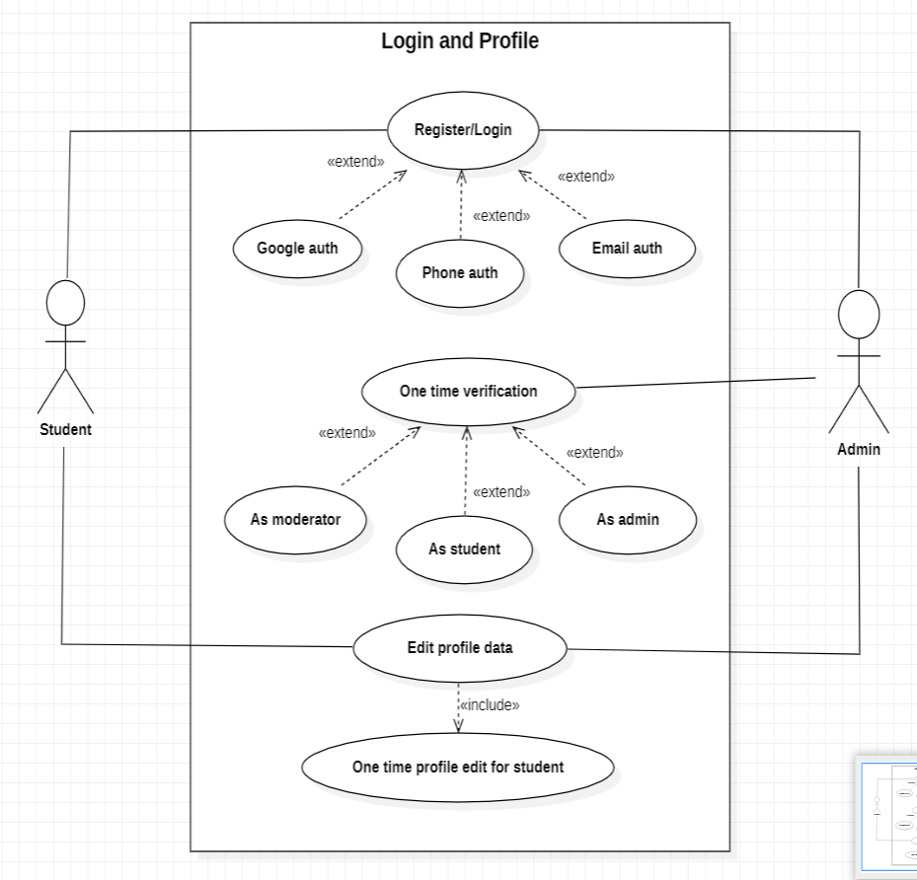

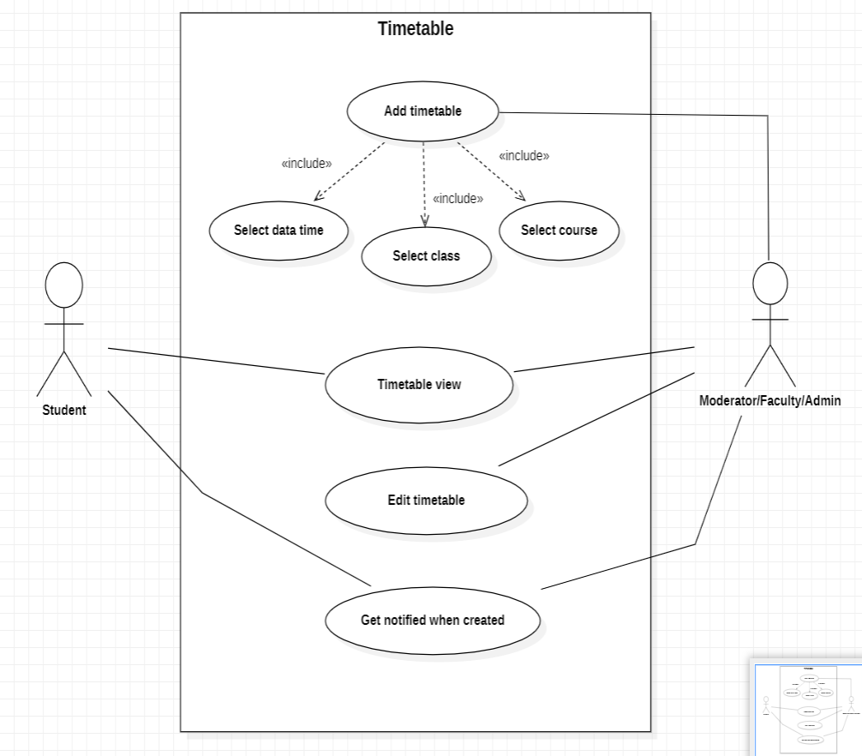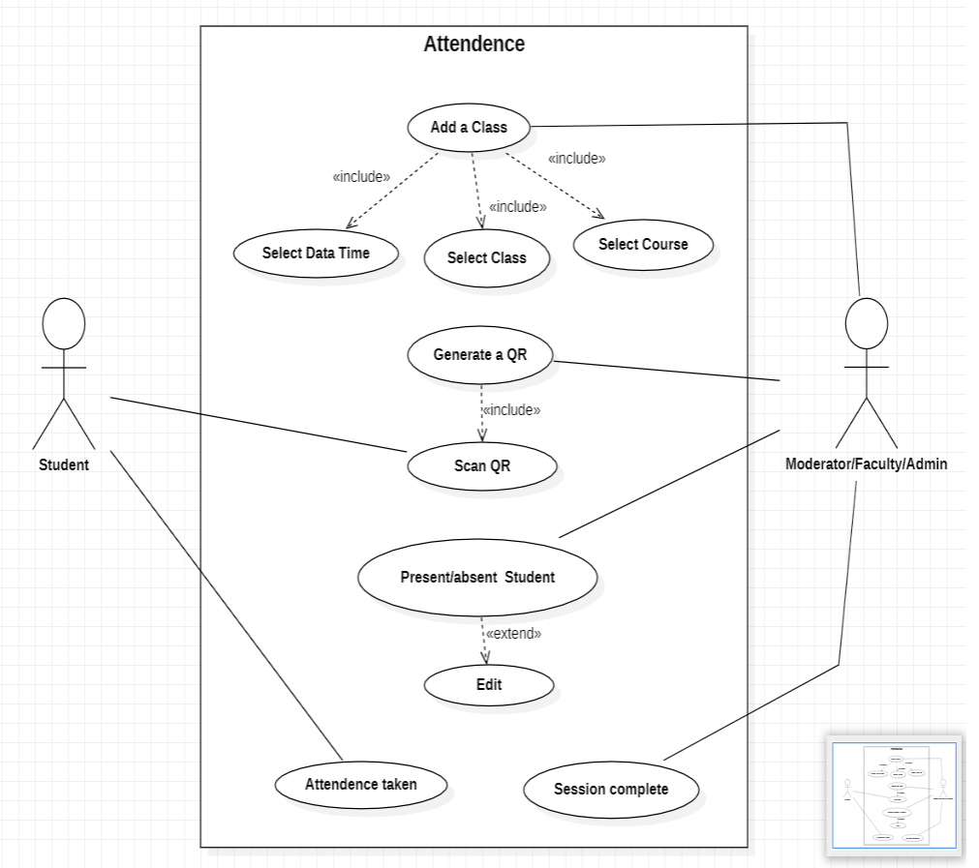

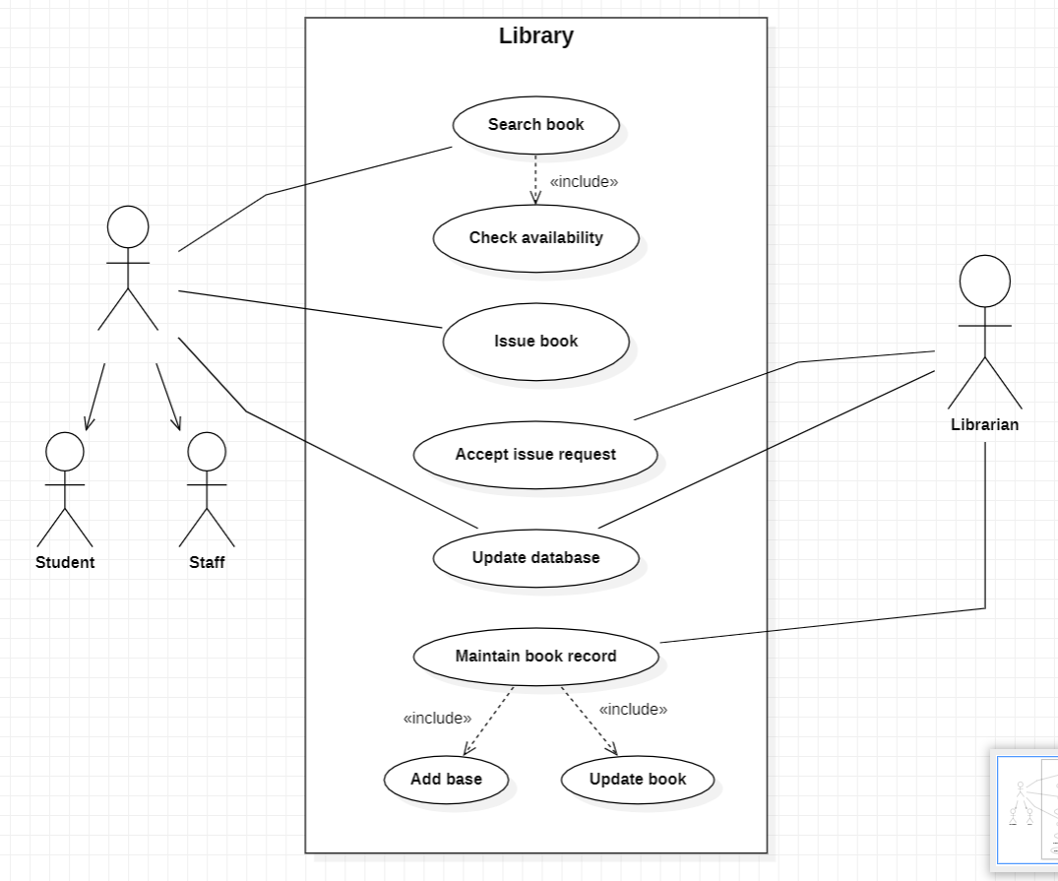

User Interfaces

Sign in/Register

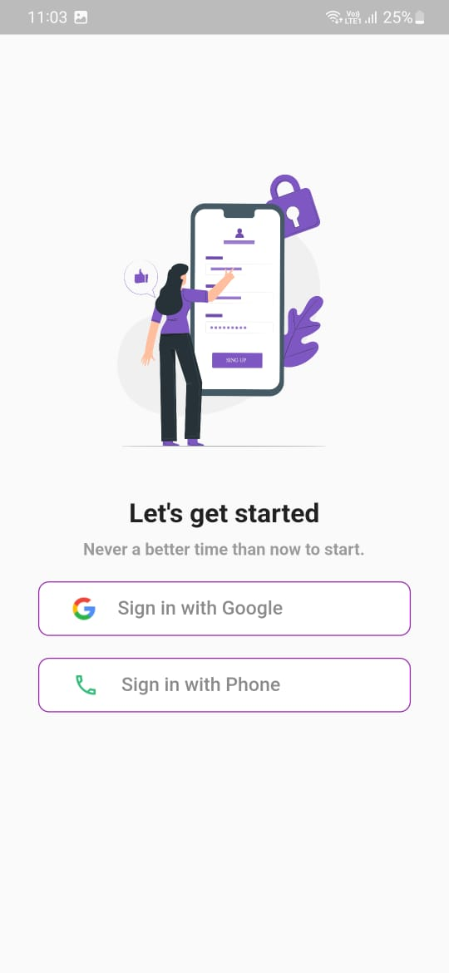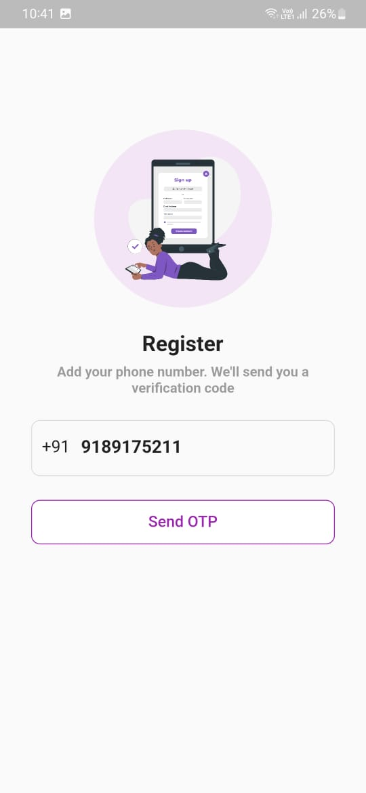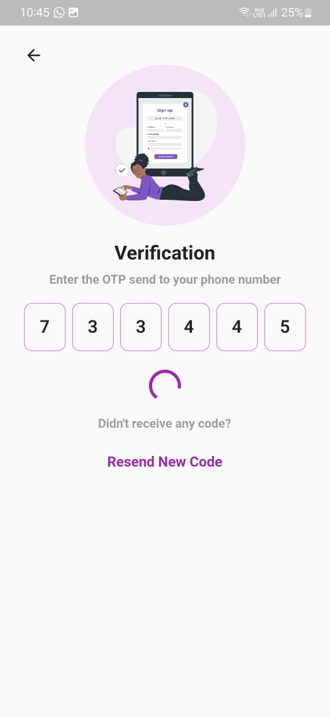

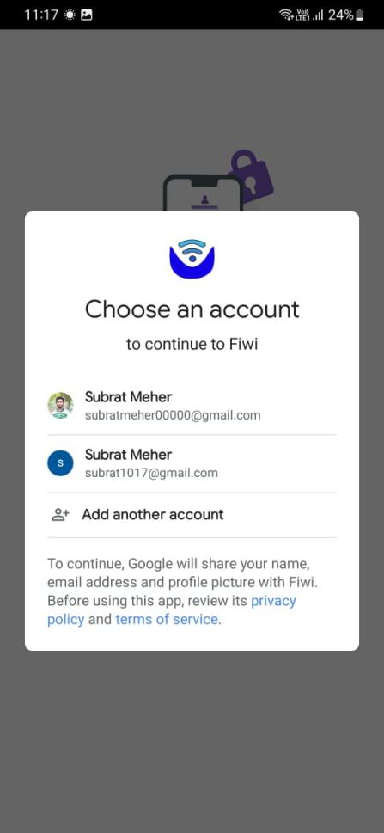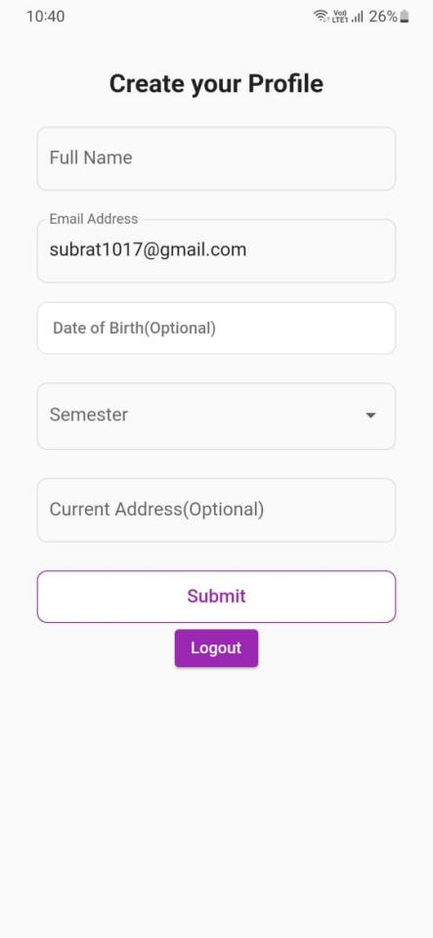

Notification

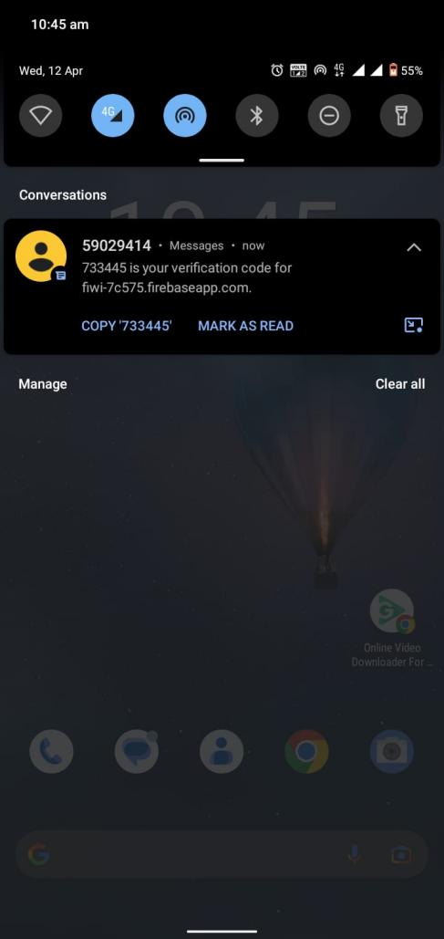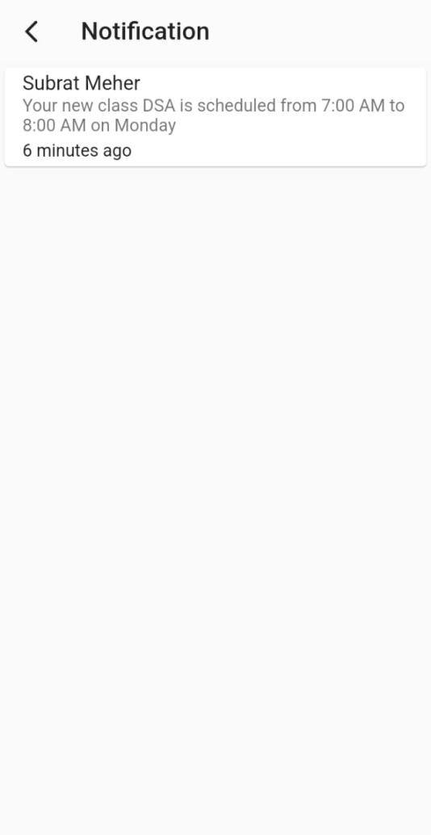

Timetable

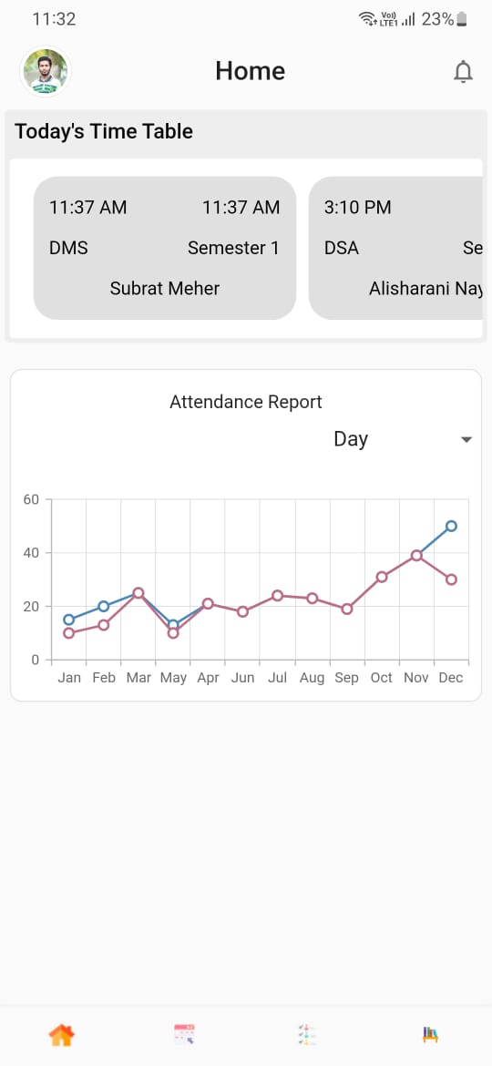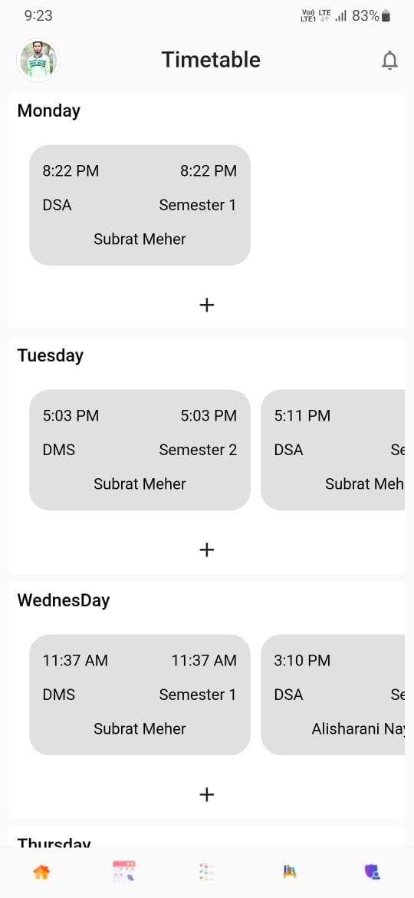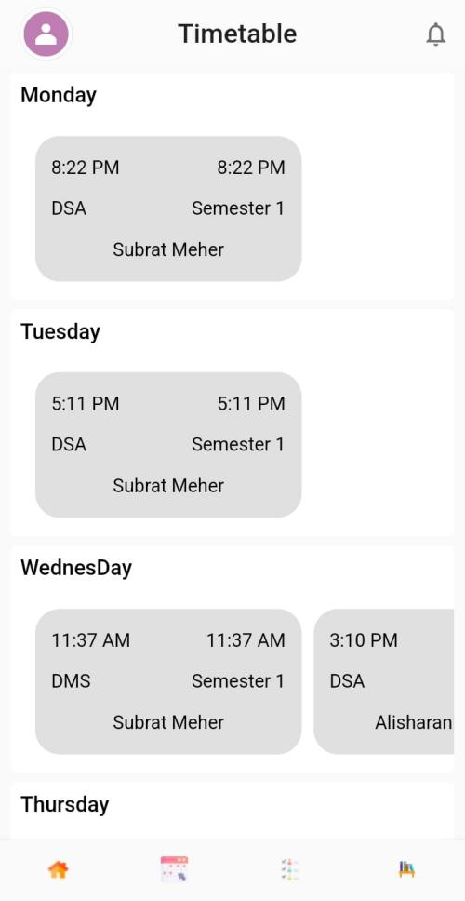

Profile

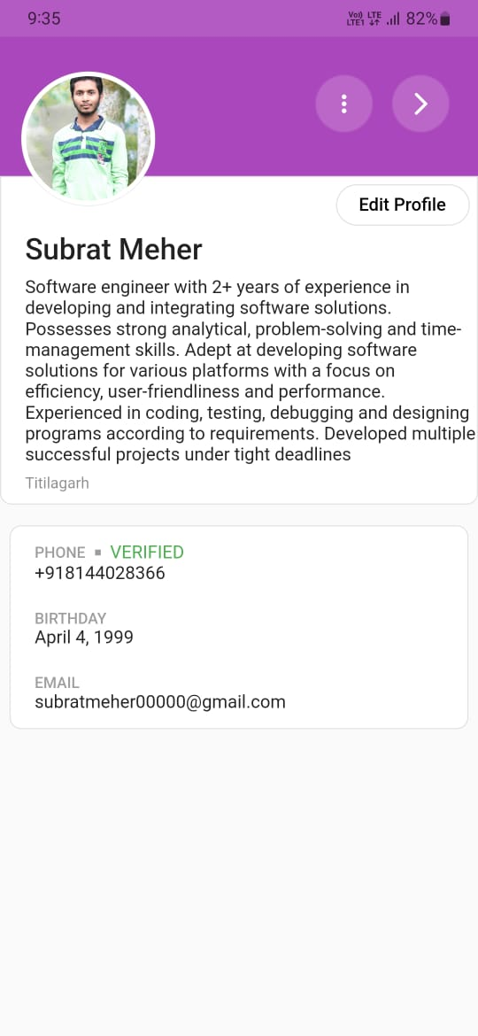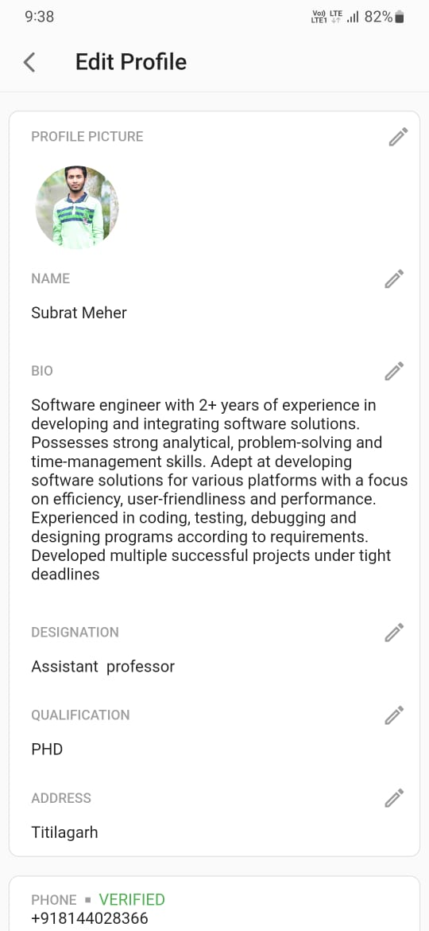

Admin Panel

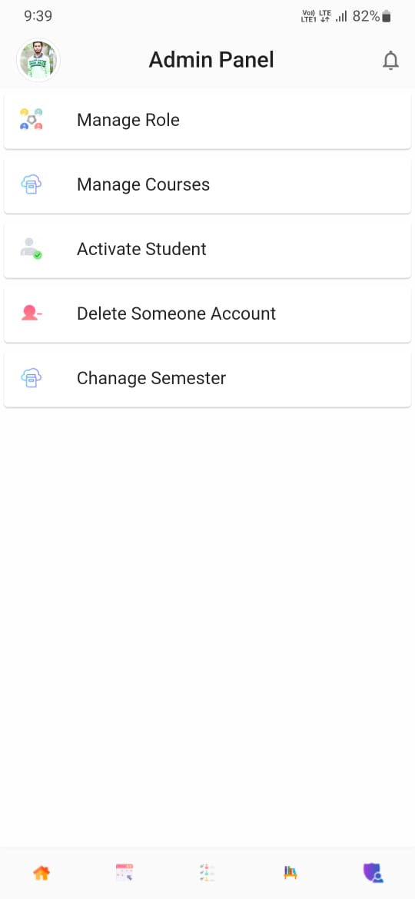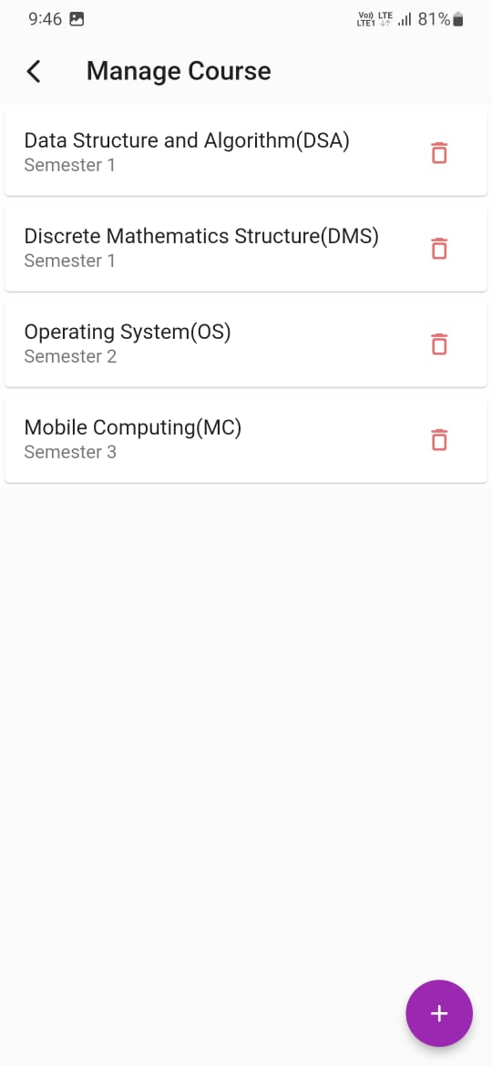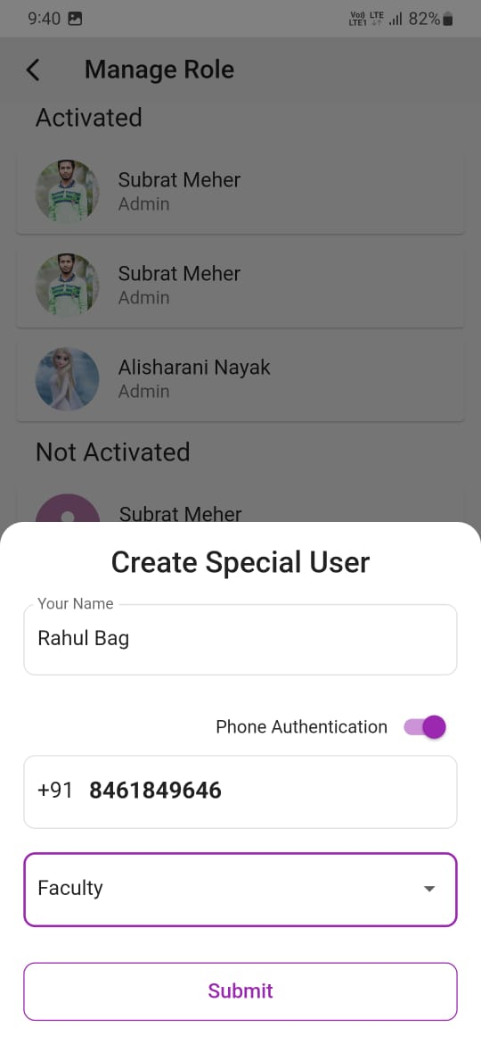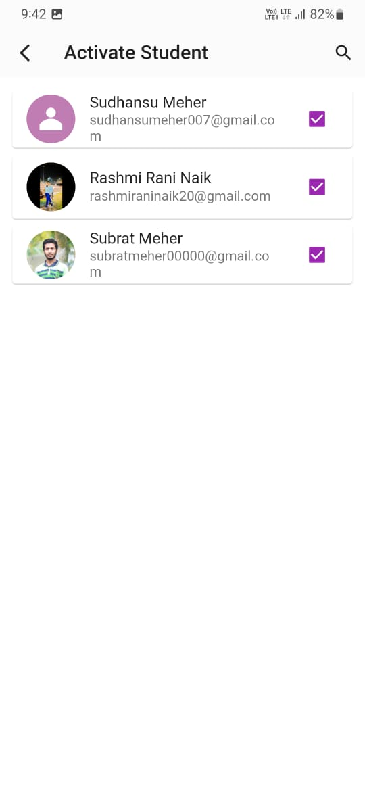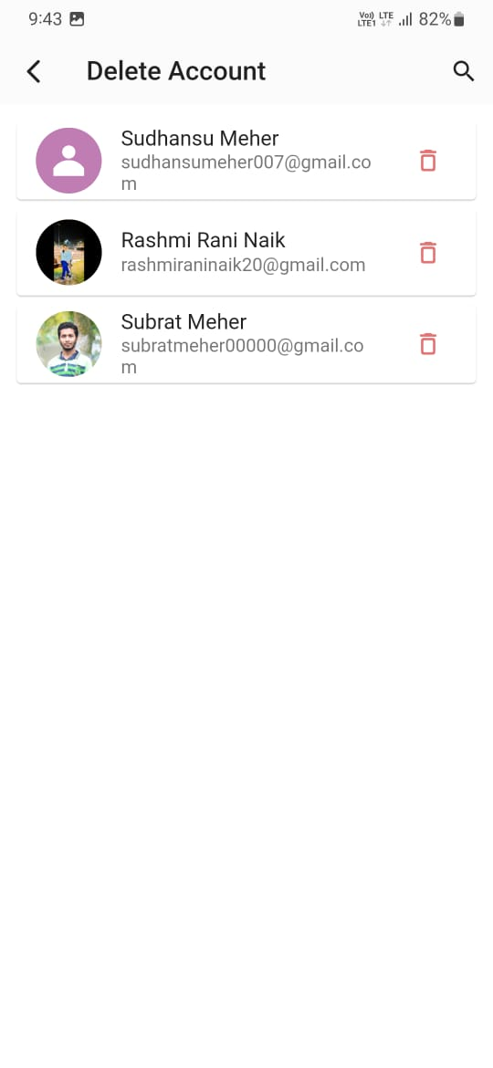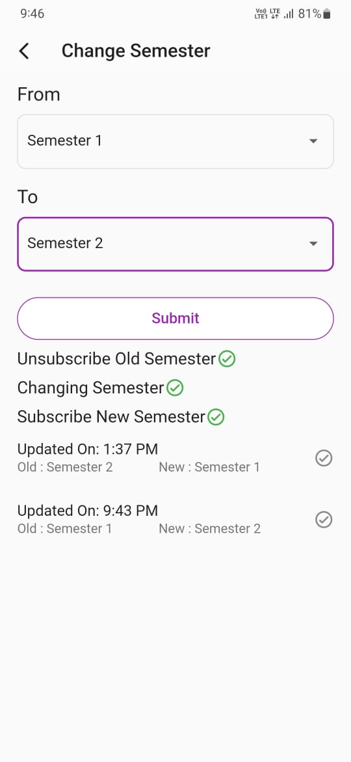

Conclusion

In this final chapter, the final evaluation & conclusion will be performed on the basis of testing & analyzing process that are being done in the previous chapter including the seminar linkage, strengths, weakness & future enhancement of the student management system “Fiwi”. In addition, personal reflection also includes in final part of this chapter.

We have discussed about the project background, project schedule, methodology used & the developing environment & operating environment.

We have faced few problems during system planning. First thing is that the app development is not been targeted for any company. We developed it by our own skills & need. It is being developed for non-commercial purpose & any one can use this app. It has student requirement facilities.

Project Management Issues

During the development process of Fiwi. We have encountered with a lot of issues. Firstly, we don’t have much knowledge & idea about my module & other module. We have done a lot of research, from internet, books to get stability in preparing this app.

On the other hand, We met problems during the construction of DFD & other class diagrams. We do research about system objectives & system requirements. Besides that, we need to construct the Level 0 Data Flow Diagram (DFD) as well as Level 1 DFD. We meet a lot of problems during construction of DFD diagram.

The lesson we learn in this chapter is we must try not to forget what we have learnt in the college because, in future we might need it in future. In addition, We found the Level 0 DFD is very useful because, it can let next programmer or user to understand how the system works.

Evaluation of project’s Strengths & Weakness

* System response is fast after user tap the screen to perform some actions.
* User interface is considered user friendly & ease of use.
* Validation has been done to avoid some functional error in later time.
* Some list view control has been included to allow user view the history or some important data without print out the report.
* Some important data is generated automatically such as User ID, & User registration data to minimize user input error.

Bibliography

Books-

1. Beginning Flutter: A Hands On Guide to App Development by Marco L. Napoli
2. Flutter in Action by Eric Windmill
3. Flutter for Beginner by Alessandro Blessek
4. Learning Dart by Dzenan Ridjanovic and Ivo Balbert
5. Practical Flutter by Frank W. Zametti

Websites-

1. <https://flutter.io>
2. <https://pub.dev>
3. <https://firebase.google.com>
4. <https://stackoverflow.com>
5. <https://medium.com>
6. <https://dartpad.dartlang.org>
7. <https://dart.dev>
8. <https://github.com>
9. <https://bitbucket.org>
10. <https://udemy.com>
11. <https://learncodeonline.in>
12. <https://udacity.com>
13. <https://hacker.io>
14. <https://freecodecamp.org>
15. <https://blogspot.com>
16. <https://telegram.me>
17. <https://youtube.com>

YouTube Channels followed

1. Flutter
2. Firebase
3. Fireship
4. Angularfire
5. MTECHVIRAL
6. Reso Coder
7. The Net Ninja
8. Traversy Media
9. Google Developers
10. Filled Stacks
11. Raja Yogan
12. London App Brewery